Regional Operational Plan DF.#R.YY-XX

Kenai Peninsula Invasive Northern Pike Monitoring and Native Fish Restoration

by

Robert Massengill, Robert Begich and Kristine Dunker

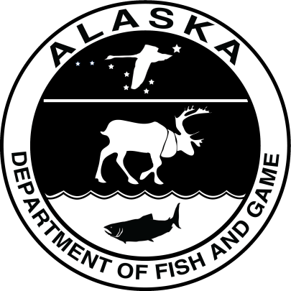

June 2018

Alaska Department of Fish and Game Divisions of Sport Fish and Commercial Fisheries

Symbols and Abbreviations

The following symbols and abbreviations, and others approved for the Système International d'Unités (SI), are used without definition in the following reports by the Divisions of Sport Fish and of Commercial Fisheries: Fishery Manuscripts, Fishery Data Series Reports, Fishery Management Reports, and Special Publications. All others, including deviations from definitions listed below, are noted in the text at first mention, as well as in the titles or footnotes of tables, and in figure or figure captions.

**Weights and measures (metric)**

centimeter cm

deciliter dL

gram g

hectare ha

kilogram kg

kilometer km

liter L

meter m

milliliter mL

millimeter mm

**Weights and measures (English)**

cubic feet per second ft3/s

foot ft

gallon gal

inch in

mile mi

nautical mile nmi

ounce oz

pound lb

quart qt

yard yd

**Time and temperature**

day d

degrees Celsius °C

degrees Fahrenheit °F

degrees kelvin K

hour h

minute min

second s

**Physics and chemistry**

all atomic symbols

alternating current AC

ampere A

calorie cal

direct current DC

hertz Hz

horsepower hp

hydrogen ion activity pH

(negative log of)

parts per million ppm

parts per thousand ppt,

‰

volts V

watts W

**General**

Alaska Administrative

Code AAC

all commonly accepted

abbreviations e.g., Mr., Mrs., AM, PM, etc.

all commonly accepted

professional titles e.g., Dr., Ph.D.,

R.N., etc.

at @

compass directions:

east E

north N

south S

west W

copyright ©

corporate suffixes:

Company Co.

Corporation Corp.

Incorporated Inc.

Limited Ltd.

District of Columbia D.C.

et alii (and others) et al.

et cetera (and so forth) etc.

exempli gratia

(for example) e.g.

Federal Information

Code FIC

id est (that is) i.e.

latitude or longitude lat or long

monetary symbols

(U.S.) $, ¢

months (tables and

figures): first three

letters Jan,...,Dec

registered trademark ®

trademark ™

United States

(adjective) U.S.

United States of

America (noun) USA

U.S.C. United States Code

U.S. state use two-letter abbreviations (e.g., AK, WA)

**Mathematics, statistics**

*all standard mathematical*

*signs, symbols and*

*abbreviations*

alternate hypothesis HA

base of natural logarithm *e*

catch per unit effort CPUE

coefficient of variation CV

common test statistics (F, t, χ2, etc.)

confidence interval CI

correlation coefficient

(multiple) R

correlation coefficient

(simple) r

covariance cov

degree (angular ) °

degrees of freedom df

expected value *E*

greater than >

greater than or equal to ≥

harvest per unit effort HPUE

less than <

less than or equal to ≤

logarithm (natural) ln

logarithm (base 10) log

logarithm (specify base) log2, etc.

minute (angular) '

not significant NS

null hypothesis HO

percent %

probability P

probability of a type I error

(rejection of the null

hypothesis when true) α

probability of a type II error

(acceptance of the null

hypothesis when false) β

second (angular) "

standard deviation SD

standard error SE

variance

population Var

sample var

Regional Operational plan DF.#R.YY-XX

By

Robert Massengill, Robert Begich and Kristine Dunker

Alaska Department of Fish and Game, Division of Sport Fish, Anchorage.

Alaska Department of Fish and Game

Division of Sport Fish

June, 2018

The Regional Operational Plan Series was established in 2012 to archive and provide public access to operational plans for fisheries projects of the Divisions of Commercial Fisheries and Sport Fish, as per joint-divisional Operational Planning Policy. Documents in this series are planning documents that may contain raw data, preliminary data analyses and results, and describe operational aspects of fisheries projects that may not actually be implemented. All documents in this series are subject to a technical review process and receive varying degrees of regional, divisional, and biometric approval, but do not generally receive editorial review. Results from the implementation of the operational plan described in this series may be subsequently finalized and published in a different department reporting series or in the formal literature. Please contact the author if you have any questions regarding the information provided in this plan. Regional Operational Plans are available on the Internet at: <http://www.adfg.alaska.gov/sf/publications/>.

Robert Massengill, Robert Begich and Kristine Dunker

Alaska Department of Fish and Game, Division of Sport Fish,

333 Raspberry Road, Anchorage, AK 99518

This document should be cited as follows:

Massengill, R., L. R. Begich and K. Dunker. 2018. Kenai Peninsula Invasive Northern Pike Monitoring and Native Fish Restoration. Alaska Department of Fish and Game, Division of Sport Fish, Regional Operational Plan ROP.DF.#R.YY-XX, Anchorage.

The Alaska Department of Fish and Game (ADF&G) administers all programs and activities free from discrimination based on race, color, national origin, age, sex, religion, marital status, pregnancy, parenthood, or disability. The department administers all programs and activities in compliance with Title VI of the Civil Rights Act of 1964, Section 504 of the Rehabilitation Act of 1973, Title II of the Americans with Disabilities Act (ADA) of 1990, the Age Discrimination Act of 1975, and Title IX of the Education Amendments of 1972.

**If you believe you have been discriminated against in any program, activity, or facility please write:**

ADF&G ADA Coordinator, P.O. Box 115526, Juneau, AK 99811-5526

U.S. Fish and Wildlife Service, 4401 N. Fairfax Drive, MS 2042, Arlington, VA 22203

Office of Equal Opportunity, U.S. Department of the Interior, 1849 C Street NW MS 5230, Washington DC 20240

**The department’s ADA Coordinator can be reached via phone at the following numbers:**

(VOICE) 907-465-6077, (Statewide Telecommunication Device for the Deaf) 1-800-478-3648,

(Juneau TDD) 907-465-3646, or (FAX) 907-465-6078

**For information on alternative formats and questions on this publication, please contact:**

ADF&G, Division of Sport Fish, Research and Technical Services, 333 Raspberry Rd, Anchorage AK 99518 (907) 267-2375

Signature Page

|  |  |
| --- | --- |
| Project Title: | Kenai Peninsula Invasive Northern Pike Monitoring and Native Fish Restoration |
| Project leader(s): | Robert Massengill, Robert Begich and Kristine Dunker |
| Division, Region, and Area | Division of Sport Fish, Region II, Soldotna Office |
| Project Nomenclature: | Northern pike, Invasive species, Kenai Peninsula, Gillnets, eDNA, Eradication, Restoration |
| Period Covered | July 2018 – June 2020 |
| Field Dates: | 1 July, 2018 – 31 October, 2018; 1 April, 2019 – 30 June, 2019  1July, 2019 – 31 October, 2019; 1 April, 2020 – 30 June, 2020 |
| Plan Type: | Category II |

**Approval**

|  |  |  |  |  |  |  |
| --- | --- | --- | --- | --- | --- | --- |
| Title |  | Name |  | Signature |  | Date |
| Project co-leader |  | Rob Massengill |  |  |  |  |
| Project co-leader |  | Robert Begich |  |  |  |  |
| Project co-leader |  | Kristine Dunker |  |  |  |  |
| Biometrician |  | Benjamin Buzzee |  |  |  |  |
| Research Coordinator |  | Tim McKinley |  |  |  |  |

TABLE OF CONTENTS

Page

LIST OF TABLES iii

LIST OF FIGURES iii

LIST OF APPENDICES iii

abstract 1

background 1

Primary Objectives 3

Methods 4

Study Area 4

Study Design for Primary Objectives 1 and 2 4

Gillnet Sampling Effort for Primary Objectives 1 and 2 5

Substitute eDNA Sampling 9

Protocol for New Pike Discoveries 13

Site Evaluations 13

Control Actions 15

Native Fish Restoration and Monitoring 16

Estimating Length Composition 17

Estimating CPUE 17

Data Collection 17

Gillnet and Minnow Trapping 17

eDNA Sampling 18

Lake Mapping 18

Water Quality Monitoring 18

Stream Discharge 18

Invertebrate Surveys 18

Data Analysis 18

Northern Pike Surveys 18

CPUE 19

Water Quality and Stream Discharge Monitoring 19

Schedule and Deliverables 20

RESPONSIBILITIES 21

reference cited 22

Appendices 26

# LIST OF TABLES

Table 1. Percentiles from the predictive distribution of K. 7

Table 2. Probability of failing to detect a population of 4 pike with various levels of net density (nets per surface acre (sa)) and net hours. 8

Table 3. Probability of failing to detect a population of 20 pike. 8

Table 4. Number of samples required to achieve the desired probability of detection. 13

# LIST OF FIGURES

Figure 1. Map of the native and invasive range of northern pike in Alaska 2

Figure 2. Map showing the status of Kenai Peninsula pike waters. 3

Figure 3. Prediction distribution for K, the average probability a fish is captured in a new removal experiment with one unit of effort. Tick marks along the x-axis show the median values for Kj, the average probability a fish is captured with one unit of effort in each of the previous removal experiments. 7

# LIST OF APPENDICES

Appendix 1. Threat ranking of Unrestored waterbodies that may be surveyed for northern pike. 26

Appendix 2. Unrestored waterbody threat ranking flowchart 27

Appendix 3. Survey schedule for Restored waterbodies. 28

Appendix 4. List of Restored waterbodies requiring gillnet surveys to monitor native fish restoration. 29

Appendix 5. Biomeme DNA extraction and thermocycler protocol from Sepulveda et. al. 2018 31

Appendix 6. Lake mapping Quick Reference Standard Operating Procedure provided by BioBase™. 32

Appendix 7. Water quality field data sheet. 34

Appendix 8. Stream discharge field data sheet. 35

# abstract

This project will conduct surveys to detect invasive northern pike and evaluate the success of efforts to eradicate them. Where northern pike have been successfully eradicated, this project will aid in restoring and monitoring native fisheries. Northern pike detection will be accomplished primarily by gillnet surveys using a standardized protocol that adjusts netting effort to lake surface area. Prioritizing which waters to survey for northern pike will be founded on a risk assessment. In waters where gillnetting is undesirable, environmental DNA (eDNA) detection methods may be used alone or in tandem with gillnetting efforts. When northern pike are detected in a waterbody, this project will collect the baseline environmental and biological data necessary to inform decision-makers who will plan a control action.

Native fish restoration will often be accomplished by collecting wild fish from a source area and releasing them to affected waters whenever natural recolonization is difficult or unlikely. Previously hatchery-stocked waters later invaded by northern pike will resume hatchery stocking once the northern pike population is removed. Assessments of restored native fish populations will utilize gillnet and minnow trap surveys to produce Catch-Per-Unit-Of -Effort (CPUE) and length frequency distributions for each species present.

Key words: Northern pike, *Esox Lucius*, restoration, CPUE, invasive, rotenone, eDNA

# background

In Alaska, south and east of the Alaska Range northern pike are considered an invasive species (Figure 1) and are implicated in the decline of native fisheries throughout the region (Rutz 1999; Sepulveda et. al. 2013; Sepulveda et. al. 2015; Glick and Willette 2016; Patankar and Von Hippel 2006). There is evidence that northern pike prefer soft-finned juvenile salmonids over other available prey species in southcentral Alaska (Sepulveda et. al. 2013; Pankatar 2006). Consumption of native juvenile salmonids by introduced northern pike has also been observed elsewhere in the northwestern United States (Rich 1992, McMahon and Bennett 1996, Schmetterling 2001, Muhlfeld et al. 2008). In Southcentral Alaska, prey of northern pike may be particularly vulnerable because they evolved in the absence of these predators whereas in interior Alaska, native northern pike share an evolutionary history with their prey which evolved adaptations for predator-avoidance (Oswood et al. 2000). Also, prevalent shallow lake morphology throughout much of southcentral Alaska offers limited deep water refugia for northern pike prey because northern pike typically occupy habitat that is shallow and vegetated (Cook and Bergersen. 1988, Inskip 1986).

Introduced northern pike were first documented on the Kenai Peninsula in the Soldotna Creek drainage in the 1970’s (ADFG unpublished). Over decades, subsequent dispersal and more illegal introductions resulted in northern pike occurring in at least twenty-four Kenai Peninsula waterbodies (Figure 2). Eleven of these waterbodies first had their northern pike populations detected since 2000, however the date of these introductions remains unknown. Kenai Peninsula northern pike have reduced or eliminated wild and hatchery-produced fish populations from some lakes (Begich 2005, Begich and McKinley 2010; McKinley 2013 and Massengill 2014a; 2014b). Beginning in 2008, the Alaska Department of Fish and Game (ADFG) initiated a program to eradicate northern pike from the Kenai Peninsula. Initial efforts focused on eradicating northern pike from landlocked lakes (Massengill 2014a; 2014b) followed by eradication efforts in progressively complex and open waterbodies within the Swanson River and Soldotna Creek drainages. Currently, the Tote Road Pike Lakes (TRPL) harbors the last known northern pike population on the Kenai Peninsula.

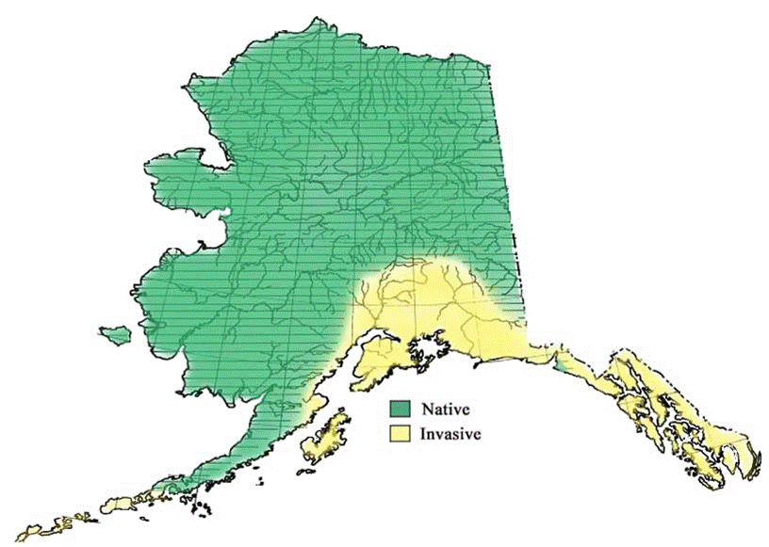

Figure . Map of the native and invasive range of northern pike in Alaska

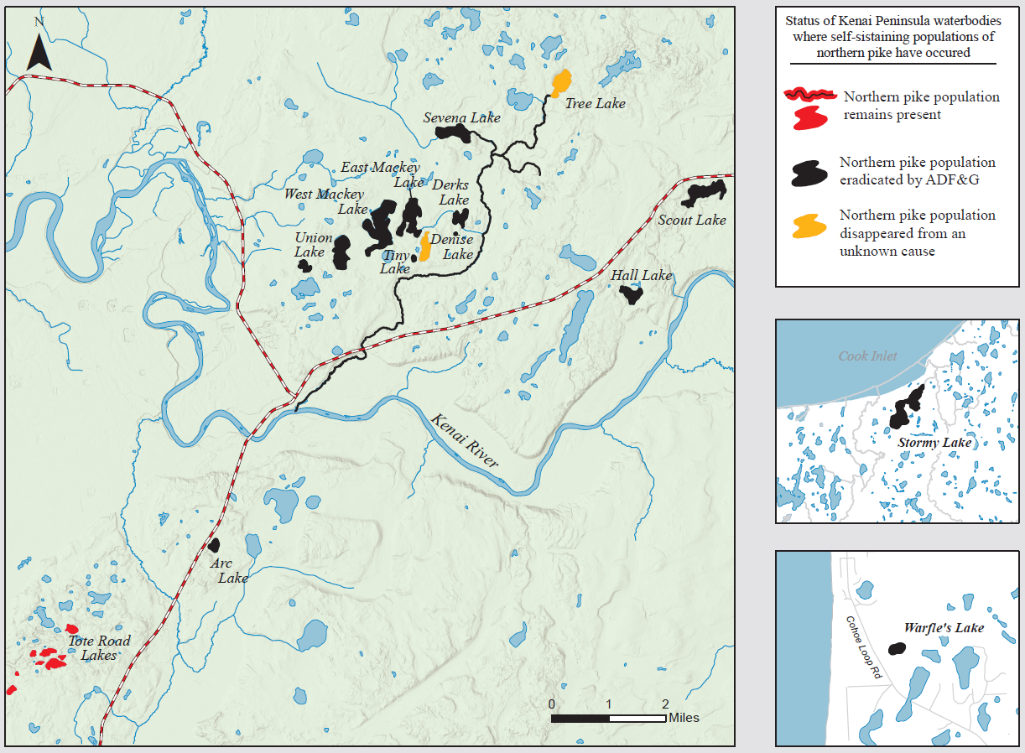

Figure . Map showing the status of Kenai Peninsula pike waters.

# Primary Objectives

This project will provide information to managers on the presence and distribution of invasive northern pike, evaluate the status of restored native fisheries in former pike waters, collect wild native fish for restoration purposes and collect baseline environmental and biological data in waters where new pike populations are detected. The primary objectives of this project are:

1. Survey to detect the presence of northern pike in a minimum of eight high threat waters that are void of native salmonids during the open water season each year between July 1, 2018 and June 30, 2020 such that the probability of detection is 0.80 given the population is at least 20 northern pike > 300mm.

2. Survey to detect the presence of northern pike in a minimum of four high threat waters that have native salmonids present during the open water season each year between July 1, 2018 and June 30, 2020 such that the probability of detection is 0.50 given the population is at least 20 northern pike > 300mm.

Secondary Objectives:

1. Collect and analyze northern pike eDNA samples for all waters where gillnet surveys are undesirable or insufficient to meet precision criteria for Objectives 1 or 2.

2. Map all waters where new pike discoveries are made to verify surface acreage and volume.

3. Measure water quality (temperature, DO, pH, specific conductance) monthly for one calendar year from any waters where new pike discoveries are made.

4. In every waterbody where northern pike have been removed, at least once every three years, for a six year period following their removal, calculate the mean gillnet and minnow trap catch-per-unit-of -effort (CPUE) of all salmonids collected

5. In every waterbody where northern pike have been removed, at least once every three years, for a six year period following their removal, collect Fork Length (FL) of all salmonids collected in gillnets and minnow traps for length composition purposes.

6. Inventory dominant invertebrate taxa from any waters where new pike discoveries are made.

7. Prepare a pike eradication/control plan for all waters where new pike discoveries are made.

8. When feasible, implement a quick-response pike control/eradication plan as soon as practical.

9. Collect wild native fish and release them into waters where restoration of the native fish assemblage is appropriate following the removal of invasive northern pike.

10. Estimate the length composition of all salmonid species present in surveyed lakes in 50 mm increments during FY19 and FY20..

# Methods

## Study Area

The study area encompasses the entire Northern Kenai Peninsula Management Area (NKPMA) with an emphasis on waters categorized as high threat for the presence of northern pike. In general, high threat waters include the Soldotna Creek Drainage, Moose River Drainage, Swanson River Drainage and any waters where pike have ever been confirmed

### Study Design for Primary Objectives 1 and 2

The goal with primary objectives 1 and 2 is to define northern pike presence in Kenai Peninsula waters considered most at risk for invasion primarily using gillnet surveys. Appendix 1 provides a list of unrestored lakes to potential survey for northern pike, where no invasive fish have been confirmed or eradicated, and the criteria for ranking the threat of pike presence in selected waters on the Kenai Peninsula (Appendix 2).

Gillnets are frequently used for the detection and suppression of invasive northern pike in Alaska (Rutz et. al., *In Prep*, Glick and Willette 2016, Sepulveda 2013, Massengill 2010). Gillnets are most effective when fished in the optimal habitat for northern pike which typically includes slow flow or lentic waters, side sloughs, embankments, and densely vegetated littoral zones (Inskip 1982). This study will conduct detection surveys (primarily gillnetting but potentially assisted with eDNA surveys) to assess the presence or absence of northern pike. Different survey protocols will be followed according to which of three categories the waterbody is assigned. Definitions for the waterbody categories are as follows:

(Restored (R)): A Restored waterbody is one where northern pike eradication has been conducted. All restored waters must have a detection survey, satisfying precision criteria for Primary Objective 1, completed within six months of the eradication effort to assess the success of the eradication effort (objective). Additional gillnet and minnow trap surveys will occur at least once every three years for a six year period post-eradication with enough effort to satisfy Secondary Objective 4 requirements. These subsequent surveys are designed to monitor restored native fish populations. A survey schedule for these waters is for Restored waterbodies is found in

(Unrestored/Salmonids Present (USP)) A waterbody where northern pike presence is unconfirmed and a survey to detect them is warranted. The waterbody is also known to contain salmonids so the netting effort will be reduced to satisfy precison criteria for Primary Objective 2.

(Unrestored/Salmonids Absent (USA)) A waterbody where northern pike presence is unconfirmed and a survey to detect them is warranted. The waterbody is not known to contain salmonids so the netting effort will be sufficient to satisfy precison criteria for Primary Objective 1.

Unrestored waterbodies will also be given a threat ranking that prioritizes them for how quickly they are surveyed. There are three threat rankings (High, Medium and Low). A threat rank is assigned if just one criterion for that rank is met (Appendix 2). In stances where a waterbody meets criterion for two different rankings, the waterbody will be assigned the highest ranking of those it qualifies for. For instance, if a lake satisfies criterion for both a Medium and High threat waterbody, it will be assigned as a High threat waterbody. When a waterbody receives a threat ranking, that waterbody waters must be surveyed within the time period described in Appendix 1. All pike and salmonids caught in any survey will be measured for fork length (FL).

Restored waters will be surveyed

### Gillnet Sampling Effort for Primary Objectives 1 and 2

Gillnet surveys designed to detect northern pike presence will be conducted with enough effort to satisfy precision criteria for Objective 1 or 2 precision according to their category (R, USP or USA). To quantify the netting effort necessary to detect a northern pike population of at least 20 fish with an estimated probability of detection of 80% and 50%, respectively for each objective, we utilized data from past northern pike removal experiments.

Between 2005 and 2010, ADF&G conducted 12 removal experiments with northern pike populations on the Kenai Peninsula using similar gillnetting methods. Data collected from these experiments included catch and effort (in units of net-hours per surface acre) for sample and experiment Populations were assumed to be closed except for fish caught and fishing was assumed to represent a Poisson process with a constant probability of capture for all individuals. Data were analyzed using a hierarchical version of Leslie’s regression method (Seber 1982):

where:

= the initial population size in experiment j

= average probability that a northern pike of any size is captured with one unit of effort during experiment j,

The probabilities of capture for each experiment are assumed to come from a common distribution:

The analysis was conducted using the RJAGS package (Plumber 2013) within R (R Core Team 2016). Non-informative priors were used for all parameters. Although Leslie’s method is typically used to estimate the initial population size our interest was in the posterior and predictive distributions of for the purpose of estimating the probability of detecting small pike populations in future removal experiments.

Percentiles from the predictive distribution for the value of *K* in a new removal experiment are shown in Table 1 and the predictive distribution is shown in Figure 1.

Table 1. Percentiles from the predictive distribution of K.

|  |  |
| --- | --- |
| Percentile | Predicted *K* |
| 5% | 0.001 |
| 10% | 0.003 |
| 50% | 0.019 |
| 90% | 0.055 |
| 95% | 0.073 |

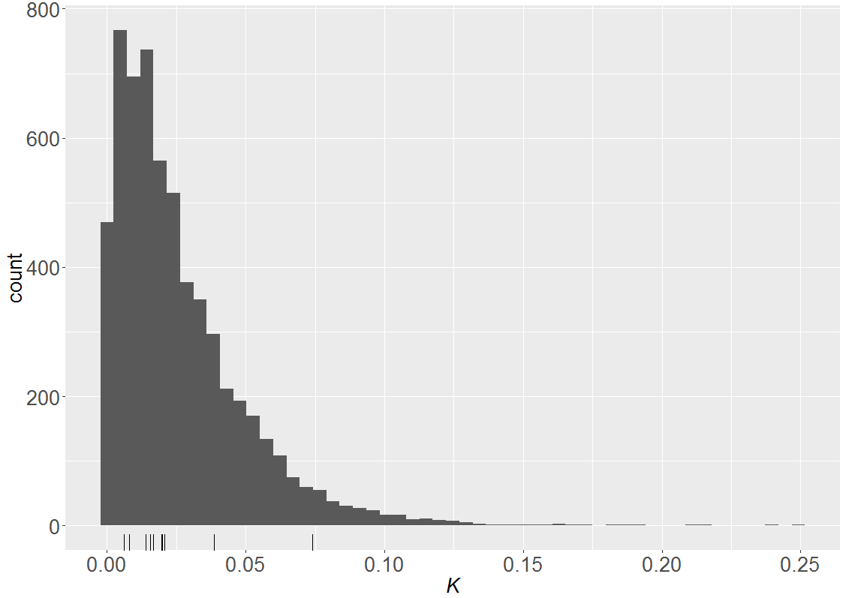

Figure 3. Prediction distribution for K, the average probability a fish is captured in a new removal experiment with one unit of effort. Tick marks along the x-axis show the median values for Kj, the average probability a fish is captured with one unit of effort in each of the previous removal experiments.

Under the assumption that fishing represents a Poisson counting process, the probability of failing to detect a population of pike of size N as a function of net-hours per acre (E) is:

We will use the median value of K from Table 1 to calculate probabilities listed in Tables 2 and 3. The netting effort and associated probabilities found in Table 3 will be used to satisfy precision criteria found in Objectives 1 and 2. Table 2 is provided for rare occasions when additional netting effort is needed to detect a very small northern pike population (4 individuals) and only done when the department or area staff determine the bycatch risk associated with increased netting effort is outweighed by the concern over potential northern pike presence.

Table . Probability of failing to detect a population of 4 pike with various levels of net density (nets per surface acre (sa)) and net hours.

|  |  |  |  |  |  |  |
| --- | --- | --- | --- | --- | --- | --- |
|  | Net Densities | | | | | |
| Netting Hours | 0.1nets/sa | 0.25nets/sa | 0.5nets/sa | 0.75nets/sa | 1nets/sa | 2nets/sa |
| 24 hours | 0.829 | 0.626 | 0.392 | 0.246 | 0.154 | 0.024 |
| 48 hours | 0.688 | 0.392 | 0.154 | 0.06 | 0.024 | 0.001 |
| 72 hours | 0.57 | 0.246 | 0.06 | 0.015 | 0.004 | 0 |
| 96 hours | 0.473 | 0.154 | 0.024 | 0.004 | 0.001 | 0 |

Table . Probability of failing to detect a population of 20 pike.

|  |  |  |  |  |
| --- | --- | --- | --- | --- |
|  | Net Densities | | | |
| Netting Hours | 0.1nets/sa | 0.25nets/sa | 0.5nets/sa | 0.75nets/sa |
| 24 hours | 0.391 | 0.096 | 0.009 | 0.001 |
| 48 hours | 0.153 | 0.009 | 0 | 0 |
| 72 hours | 0.06 | 0.001 | 0 | 0 |

Based on lake surface acreage, status of salmonid presence and detection probabilities found in Tables 3, the minimum gillnet survey effort (hours and number of nets) will be such that the probability to detect a northern pike population of at least 20 individuals will be 0.80 for lakes without salmonid presence (Objective 1) and 0.50 for lakes with native salmonid presence (Objective 2).

Gillnets used for northern pike surveys will be identical to those used in the 12 removal experiments mentioned previously. The gillnets are manufactured by Duluth Nets and made of single-strand monofilament mesh hung from a polypropylene floating line with the net bottom attached to 30-lb lead line. Each net is 120 ft. long, 6 ft. deep, with six -20 ft. wide panels of size mesh (1 each of sequentially attached 0.5-inch, 0.625-inch, 0.75-inch, 1.0-inch, 1.5-inch and 2.0-inch stretched mesh) all tied with #9 twine. Gillnets will be deployed in vegetated littoral areas and fished continuously as practical. When continuous gillnetting is unsafe or logistically impractical, separate netting efforts will be repeated until the sum of netting effort achieves the effort goal. As practical, staff will be present continuously to tend the nets, and at a minimum, nets will be tended daily. If a northern pike is captured in a waterbody where the sole purpose of the survey was to determine pike presence, the netting will be halted if bycatch becomes a concern.

### Substitute eDNA Sampling

#### Background

Environmental DNA (eDNA) is the DNA from an organism shed into the environment. Organisms often shed their DNA nearly continuously from cell sloughing, waste production, carcass deposition, gamete expression and other mechanisms. Sampling for eDNA is potentially more sensitive than traditional fisheries approaches for detecting aquatic taxa in low abundance (Ficetola 2008). For aquatic species detection, eDNA is commonly collected within water samples (i.e., ~1000ml bottle), concentrated by filtration and the filtrate processed further for qPCR amplification. In circumstances when gillnetting may be an undesirable method for detecting northern pike (i.e., logistical, safety or large bycatch concerns), eDNA detection methods may be used to supplement reduced netting effort, or, to supplant gillnetting effort altogether. In those situations, an effort will be made to achieve similar precision criteria listed for Objectives 1 and 2.

ADF&G and the United States Fish and Wildlife Service (USFWS) developed and tested several genetic markers for use in detecting northern pike eDNA which resulted in the selection of a preferred marker (*EluCOI*) located in the cytochrome oxidase 1 gene of mitochondrial DNA (Olson et. al. 2015). Since 2014, ADF&G has used this marker to assess northern pike distribution and evaluate the success of northern pike eradication projects (Dunker et al. 2016) (ADF&G Unpublished[1]). Processing of the eDNA samples was done by USFWS Conservation Genetics Lab in Anchorage using a benchtop laboratory method called quantitative polymerase chain reaction (qPCR).

A portable device called Biomeme© Two is a qPCR thermocycler that provides onsite real-time eDNA processing capability. The Biomeme two3 can process 3 eDNA samples simultaneously in about one hour compared to traditional benchtop processing methods which can takes weeks or months for results depending on the lab scheduling and turn-around time. Performance testing of the Biomeme© two3 against traditional benchtop qPCR processing suggests the Biomeme two3 produces a lower probability of detection than traditional benchtop processing and requires the processing of ~1.9 samples for every sample processed by traditional benchtop qPCR methods (Sepulveda et. al. *In Prep.)*.

#### eDNA Sampling Protocol

We will adopt many of the eDNA collection and handling methods described by the United States Fish and Wildlife Service (USFWS), United States Geological Survey (USGS) and the United States Forest Service (USFS) to improve quality control that reduce the risk of contaminating or degrading eDNA samples (Wolt et. al. 2015; Carim et. al 2014 and Laramie et. al. 2015). Many factors can affect the detection and persistence of eDNA. False positive results can be caused by contamination during sample handling or processing, persistence of eDNA in the environment after the organisms is gone or the transport of eDNA. Likewise, false negative results can be caused by insufficient assay sensitivity, a method failure during sample processing (i.e., inhibition of DNA amplification), a lack of target DNA in the sample or degradation of the eDNA in the sample prior to processing (Evans 2017).

eDNA samples will be collected either by foot travel along the shoreline or from a boat. Great care will be taken to ensure outer gear worn by collectors (waders, life jackets) and collection equipment (swing sampler, transport coolers) decontaminated with a 10% bleach solution allowing for a 10-minute soak before rinsing with tap water. All sample containers will be purchased pre-sterilized or sterilized by samplers using a 20% bleach solution soak for 10 seconds of contact time followed by a deionized water or distilled water triple rinse. All decontaminated sample containers will be stored inside a clean plastic bag until used for sampling.

When sampling from a boat, to reduce the risk that the boat could transfer northern pike eDNA, the boat hull, lower unit and trailer will be first cleaned of debris with a high pressure wash followed by a 10% bleach solution spray allowing for a 10-minute contact time prior to sample collection (USFWS 2018). When samplers are collecting from a boat, they will collect the sample from the bow of the boat before the boat travels atop or beyond a sample site. Whether sampling from a boat or by foot, samplers will systematically collect samples in a sequential manner at each waterbody to avoid traveling past a sample site prior to it being sampled.

Before collecting a sample the collector will don non-powdered nitrile gloves. Water samples will be collected in duplicate 1000ml surface water grab samples collected in either a sterilized 1-liter Nalgene™ bottle or Whirl-Pak™ bag. Duplicate samples will be collected at each collection if sample processing will done using a Biomeme Two3 thermocycler to compensate for its lower detection efficiency compared to traditional benchtop qPCR processing. All sample containers will be labeled with a location code, unique sample code and collection date then placed inside a secondary Whirl-Pak™ bag and chilled by placing it on ice inside a disinfected insulated cooler until filtered. All sample locations will be recorded with a handheld GPS

Each day sampling occurs, we will collect several control blanks that will help identify whether eDNA contamination has occurred during handling or transport of the samples. Control blanks will be collected in the same sample containers and volume size as the actual lake water samples but the sample itself will consist of filling the sample with deionized water. One control, called a field blank, but will be filled with deionized water as well. The field blank will help assess whether sample contamination is introduced during field collection activities. Another control, called a travel blank, will be collected at the Soldotna Field Office prior to departure to the field and will be transported to and from the field in the same cooler used to transport the lake samples. The travel blank will help identify if sample contamination is introduced during transport. A lab blank will be collected in the same lab room where sample filtering occurs. The lab blank will serve to identify whether sample contamination is introduced during the filtering processes.

Within 2 days of sample collection, all samples will be filtered using a GeoTech series II peristaltic pump and 0.45 µm nitrocellulose membrane filters. After filtering, all filters from each unique sample will be stored together in a vial sterile whirlpak bag and placed into cold storage. Each vial will be given a unique sample ID. All field water sampling, equipment decontamination, sample filtering and storage are designed to follow established eDNA protocols (Laramie et. al. 2015). These decontamination procedures will include: 1) wearing new nitrile or latex gloves each time a new sample is handled, 2) using only sterilized tweezers to handle filters, and 3) sterilizing all filtering assemblies prior to use in a 50% bleach solution (50% deionized water: 50% household bleach containing 8.25% hypochlorite) bath for 10-15 minutes followed by two deionized water baths. The filter assemblies will be reassembled after sterilization and then rinsed again by pumping 0.5-1.0 L of deionized water through the assembly. Before filtering a new sample, we will spray the pump and associated work area with a 10% bleach solution or DNA AWAY™ and then wipe the space dry with a sterilized tissue. Filtered samples will be placed on ice until processed by the Biomeme two3. Samples that are collected and filtered will be processed at the Soldotna ADF&G office. Sample filtrate will be extracted and analyzed using methods described by Sepulveda (*In Prep.*) and summarized below.

Filtrate extraction will be done with a Biomeme© Field Test Kit which is designed for use only with MCE filters. The Biomeme kit utilizes a filtration-based method in which DNA selectively binds to the silica membrane inside Biomeme’s proprietary sample column. Subsequent washes through a sequence of specially formulated buffers produce purified DNA upon elution. Biomeme’s six-step protocol takes ~ 5 minutes (Appendix 3). The purified DNA is then stored in the elution buffer until PCR.

To analyze DNA extract for presence of pike DNA, we will use a Biomeme two3 portable real-time thermocycler. The Biomeme two3 has two channels (FAM and Cy5) and three wells so duplicate reactions can be run for three samples simultaneously.

We will pipette 20 μl of the purified DNA into each well, which is prefilled with a lyophilized assay that includes the EluCOI marker specific to pike DNA (Olson et al. 2015). The Biomeme’s recommended thermocycler protocol for this assay is found in Appendix 4.

Output of the Biomeme two3 thermocycler is provided via a smartphone interface and includes amplification curves and the cycle number at which fluorescence increased above background values (Cq) for the pike marker (FAM channel) and for the IPC (Cy5 channel). Samples that are positive for pike DNA will be those which amplified. Samples determined to be inhibited will be those for which the IPC failed to amplify.

After processing, if multiple positive eDNA detections occur from waters where northern pike have not been physically confirmed before, and all eDNA control blank samples test negative for northern pike eDNA (no contamination suspected), this will indicate the need to conduct gillnet and ground-truth the eDNA results. A single positive eDNA detection alone will not signal the need to conduct a gillnet survey. The reason for this is ADF&G has yet to confirm northern pike presence via gillnetting when only a single eDNA sample was positive (authors; personal observation). Other states are currently developing guidelines on what conditions must be met before scoring an eDNA sample as a positive detection. Such criteria may include requiring that multiple markers located on different genomic regions amplify and that the results are reproducible in multiple labs. For this project, multiple positive eDNA detections will indicate the need to ground truth results with a gillnet survey. Only when a northern pike is physically collected will we conclude that northern pike are present in a waterbody.

Prior to collecting eDNA samples, approximate sample locations will be numbered and identified on a bathymetric map of each lake. Sample containers or bags will be labeled with the name of the lake, date, sampler initials, and unique sample ID.

#### eDNA Sampling Effort

To develop an eDNA sampling effort that is sufficiently robust to detect low abundance pike populations, we relied on the estimated mean detection probabilities of northern pike eDNA reported in Dunker (2016). The detection probabilities were estimated from results of replicate 1 liter samples collected at 1, 10, and 40 meters from a single, caged, live northern pike and were estimated to be 0.89, 0.57, and 0.27 respectively. For this project, 1-liter samples will be collected in duplicate to account for the lower detection probabilities using the Biomeme two3 device..

The following calculations will be used to estimate how many eDNA samples are needed to detect a small northern pike population (N=20) with a desired probability of detection provided lake acreage is known and no gillnet sampling occurs. Calculations will be based on the assumptions that (1) fish are randomly distributed throughout the sampling area, (2) there are no false detections, and (3) the probability of detection beyond 40 meters is zero, since no estimates are available for this region.

To account for differences in the probability of detection due to the distance between a pike and the sample site, we will decompose the 40-meter circle around each sample site into three distinct sub-regions. These sub-regions will be the circular area less than 1 meter, between 1 and 10 meters, and between 10 and 40 meters from the sample site, which we will label sub-regions 1, 2, and 3 respectively. Since Dunker (2016) estimated the probability of detection at 1, 10, and 40 meters, we will use their estimates as conservative proxies for the probability of detection over the entire respective sub-regions. If P represents the probability of detecting a pike and we let D be the event a pike is detected and be the event that a single pike is present in sub-region *i* for *i = 1,2,3*, we note by the law of total probability and the definition of conditional probabilities:

|  |  |
| --- | --- |
| P(D) = P(D | )* P() + P(D | )*P() + P(D | )* P() | (1) |

Thus, the probability a pike is detected is equivalent to the probability a pike is detected given it is in a region, times the probability it is in the region, summed over all regions. The probabilities of detection given a pike is present in the region (P(D | )) are taken as the estimates from Dunker (2016). Under the assumption that pike are randomly distributed, the probability a pike is present in a region is the proportion of total area represented by that region (, which we arrive at by computing the fixed area of each circular region and dividing by the known total surface area.

Finally, assuming sample sites are identical and there are no false positives, it can be shown that the probability of detection given the pike is at one sample site is equal to the probability of detection given the pike is at one of S sample sites for S = 1, 2, …, n. Thus the only change in our probability calculation for S sites is the proportion of area represented by each sub-region is now S*P(). By another application of the law of total probability and definition of conditional probabilities:

|  |  |
| --- | --- |
| P(a detection at S sites) = P(D | )*S* P() + P(D | )*S*P() + P(D | )*S* P() = S*P(D) | (2) |

Since the N pike are randomly distributed, the number of pike that are successfully detected follows a Bin(N, S*P(D)) distribution. The probability of at least one detection at S sites is . We then set this expression to the desired probability of detection and solve for S. Table 5 displays calculated eDNA sampling requirements for a variety of desired probabilities of detection and acreages assuming a population of 20 pike.

Table . Number of samples required to achieve the desired probability of detection.

|  |  |  |  |  |  |  |
| --- | --- | --- | --- | --- | --- | --- |
|  | Acres | | | | | |
| Probability of Detection | 10 | 25 | 50 | 75 | 100 | 200 |
| 0.5 | 1 | 3 | 5 | 8 | 10 | 19 |
| 0.75 | 2 | 5 | 10 | 14 | 19 | 38 |
| 0.9 | 4 | 8 | 16 | 23 | 31 | 61 |
| 0.95 | 4 | 10 | 20 | 30 | 39 | 78 |

## Protocol for New Pike Discoveries

### Site Evaluations

If northern pike are discovered in a waterbody, data will be collected to aid in planning a control/eradication action and to better assess the ecological threat posed by the northern pike population. Data collection will focus on documenting baseline environmental and biological conditions and containment options.

#### Lake Mapping

In new waterbodies where invasive northern pike are detected, lake bathymetry data will be collected to produce volume estimates and a bathymetric map useful for planning northern pike control/eradication efforts. To collect bathymetry data we will use a boat-mounted Lowrance™[2] HDS chartplotter and transducer to record x,y,z mapping data. The mapping will be accomplished by first mapping the lake perimeter as nearshore as feasible then repeating a perimeter circuit from ~20m further offshore. After two complete lake perimeter circuits are completed the rest of the lake can be mapped by sequential line transects, typically orientated along the greatest length of lake. On lakes with distinct bays or an irregular shape, transects can be run by section. Typically, transects lines should be < 40 meters apart; this can be gauged by watching the GPS track on the Lowrance™ unit’s monitor. Details regarding specific Lowrance™ HDS settings and mapping options can be found in Appendix 5.

#### Water Quality Monitoring

Water quality data will be collected monthly for 1 year at waters where northern pike have been discovered. Water quality data will be collected using a portable Quanta Hydrolab to record temperature pH, specific conductivity and dissolved oxygen concentration. Collection of water quality data will be in 1-meter increments starting near the deepest area of each lake and thereafter in 1 meter increments upwards to include just below the lake surface. All sampling locations will be recorded with a handheld GPS. A secchi disk will be used to measure turbidity to the nearest 0.1m. Measurements will be collected from a boat during open water and by drilling through the ice during the winter.

#### Stream Discharge

If the waterbody containing northern pike includes water inlets and/or outlets, stream discharge measurements will be collected at those sites monthly for at least one year. In addition, streams linking the infested waterbody to other waterbodies, from headwaters to the drainage’s terminus at a main stem river, will have monthly discharges measured. Stream discharge measurements will be collected with a Price Pygmy™ current meter (magnetic head) attached to a Scientific Instruments™ wading rod with an attached electronic AquaCount™ display screen[3]. Stream discharge will be collected in accordance with principals provided by the ADF&G Statewide Aquatic Resources Coordination Unit training course titled “How to Measure Stream Discharge” that comply with United States Geological Survey (USGS) specifications as described in Nolan and Shields (2000).

#### Invertebrates Surveys

Beyond fish biological data obtained by the initial gillnet survey, additional biological surveys will be conducted where northern pike are discovered.

Macroinvertebrate and plankton surveys will be collected in these waters to document the dominant taxa and their relative abundance. In each lake, zooplankton evaluations will be made at 2 sites by replicate vertical tows using a 0.5 meter diameter Wisconsin net with 153 µm mesh at different locations near maximum lake depth. The Wisconsin net will be lowered to just above the lake bottom near maximum depth and then retrieved at a rate of 1 meter every 2 seconds. Zooplankton samples will be analyzed to a reasonable degree of taxonomic resolution and relative abundance. An Ekman dredge will be used to collect bottom sediment from two sites at both lakes; sediments will be screened to extract any invertebrates for later identification. Kick nets will be used to collect invertebrates along vegetated shorelines in 5 locations. Attempts will be made to visually locate and collect freshwater mussels and snails opportunistically. All sample locations will be recorded with a GPS to ensure repeatability of site selections. All invertebrate specimens will be preserved in 90% ethanol, labeled with the date, collector initials and site location, and archived for later evaluation at the ADF&G Soldotna office.

In addition, all waterfowl, amphibians, and mammals observed during these sampling events will be noted.

#### Minnow Trapping

At each waterbody where northern pike are discovered, five minnow traps baited with salmon eggs will be fished continuously for at least one hour in an attempt to detect the presence of small or juvenile fish. Minnow traps will be fished near shoreline weed beds and in or near tributaries. Minnow trap set locations will target protective cover habitat and spacing between traps will be >50m to ensure adequate coverage.

#### Land Status

Landownership status will be identified for all lands surrounding waterbodies discovered with northern pike including lands surrounding other waters linked to the northern pike waterbody that could potentially be within a “treatment area” for a pesticide application. Land ownership can be identified using the Kenai Peninsula Borough’s online GIS mobile viewer application found at: <http://www.kpb.us/gis-dept> .

### Control Actions

#### Containment

Based on gillnet survey results and an assessment of connectivity to other waters, the physical detection of a northern pike population will require an appropriate control action. When feasible, an initial response to a northern pike detection is to immediately contain the population. This response aligns with universal early detection rapid response (EDRR) protocol for control of invasive species as found online at: <https://www.invasive.org/edrr/index.cfm>. In most instances, containment of northern pike in an open waterbody will involve installing fish passage barriers at all inlets and outlets.

Typically, containment strategies will have site-specific challenges but successful approaches used for blocking northern pike passage in small northern Kenai Peninsula streams have included installation of fyke nets or stainless steel screen panels with 1/4-inch –1/8-inch mesh. Fyke nets should be shrouded in plastic-coated wire poultry fencing to reduce animal damage that could compromise the barrier. If abrupt stream elevation drops are present near lake inlets or outlets (i.e. beaver dams, spillways, perched culverts), sometimes a relatively simple modification (i.e., sandbag layer, wooden chute installation) can create a more abrupt and defined vertical drop to reduce successful upstream northern pike passage. Little information is available quantifying the jumping ability of northern pike but anecdotal information suggests vertical drops >0.3 feet are effective to contain upstream movement (Diebel 2013).

#### Eradication

The decision to implement a control or eradication action must weigh the potential or realized consequences the northern pike population poses to ecological and economic concerns. When resources are sufficient to act quickly, a rapid response plan to eradicate with rotenone (a plant based piscicide) is a suitable option if permitting can be expedited or emergency exempted. In small closed lakes (<40 acres) intensive under-ice gillnetting has also proven to be an effective eradication alternative (unpublished data, Soldotna ADF&G Office) but only when the pike population is small (< 30 individuals) and reproduction success is low as noted by the lack of multiple age-classes or juvenile northern pike during sampling efforts. Successful eradications using gillnets alone has involved fishing gillnets continuously from fall ice-up until spring ice-out with gillnet densities of 0.5- 2.0 nets/acre (ADF&G unpublished data).

For infestations where a quick-response eradication plan is not possible, a restoration plan will be drafted to facilitate the scoping, permitting and eradication/control options available.

## Native Fish Restoration and Monitoring

#### Overview

The goal of native fish restoration is to reestablish self-sustaining native fish populations historically present but lost or severely reduced by invasive northern pike impacts. For waters that are sufficiently open to allow natural recolonization of native fish via migration and dispersal, planned releases of native fish may not be necessary for fish populations to recover. Conversely, transplanting or stocking fish may be required to successfully restore fish to some waters where natural recolonization is impeded or impossible.

Recent ADF&G practices to accomplish wild native fish restoration has generally been accomplished by two methods. The first is by collecting native fish from the pike-invaded waters, if they are still present in suitable numbers, and temporarily holding them offsite in a safe area (net pen or small closed pond) until reintroduction can occur post-eradication (Massengill *In Press.*). The second method is by collecting representative native fish from a different waterbody, ideally from within the same drainage, and releasing them into waters following the removal of northern pike (ADF&G Unpublished*[4]*). In rare circumstances, native fish brood stock may be collected from the pike-invaded water prior to the eradication effort. The brood stock can be used for producing hatchery-reared offspring that are used for reintroduction. This latter method is suggested for circumstances where the native fish population is very scarce and collecting enough individuals for reintroduction is impractical, particularly if the population is suspected of being genetically unique based on phenotypic or morphological traits (Massengill *In Press.)*.

Rainbow trout, Dolly Varden, juvenile coho salmon and threespine stickleback are the most common native species impacted by invasive northern pike on the Kenai Peninsula. Past native fish restoration efforts have focused mostly on collecting these species for reintroduction (ADF&G Unpublished Data). Maximum annual stocking densities for juvenile salmonids for this project will be based off the recommended stocking density guidelines for hatchery-stocked rainbow trout fry of ~100 fish/acre (Havens 1992). The frequency of salmonid stocking (a single year event vs. repeated annual or biannual events) will depend on characteristics of the lake, management goals and biological information gathered from post-stocking fish surveys. Previous stickleback reintroductions in Alaska following northern pike removal has been successful (Bell et.al. 2016). These stickleback introductions typically have a stocking goal of releasing several thousand reproductively mature stickleback to a waterbody during one stocking event (Bell 2016).

Minnow trapping in streams or lakes has proven to be an efficient method for collecting most juvenile native fish species and is recommended over other methods tried (i.e., backpack electrofishing, fyke net traps, hand-dipnetting) (ADF&G unpublished data).

This project will provide the resources and support for native fish restoration efforts for Restored waters as needed. Native fish restoration efforts will typically be planned and described in a “treatment plan” that is developed specifically for each eradication project. Currently there is an active treatment plan for eradicating pike and restoring native fish species in the Tote Road area south of Soldotna titled “Tote Road Pike Lakes Restoration: Northern Pike Eradication” archived at the Soldotna ADF&G office.

**Survey Effort in Restored Waters**

In every waterbody where northern pike have been removed and native fish populations restored, at least once every three years, for a six year period following the removal of northern pike, we will conduct gillnet and minnow trap surveys to monitor native fish populations. To avoid excessive impacts to restored native fish populations, gillnetting effort will be at the discretion of the project leader. In most instances, not more 24 hours of cumulative gillnetting will be applied to each lake being surveyed. Minnow trap surveys will be conducted such that five minnow traps baited with salmon eggs are fished continuously for at least one hour each.

### Estimating Length Composition

In lakes surveyed with gillnets all captured fish will be sampled for length. Length composition by size class (50mm increments) will be estimated for all salmonid species present using the method described by Thompson (1987). Accordingly, confidence intervals will only be created when sufficient sample sizes are obtained.

### Estimating CPUE

For Secondary Objective 4, mean CPUE by gear type (gillnet and minnow trap) will be calculated using standard statistical methods.

## Data Collection

### Gillnet and Minnow Trapping

All fish captured in gillnets will be identified by species counted and measured for fork length (FL; tip of nose of fork of tail). Data will be recorded on Rite-in-the-Rain notebooks and later transcribed into an Excel file. We will release all native fish species , if alive, but will dispatch all captured northern pike on-site and will record their sex, maturity, stomach contents and collect cleithra bones for aging and otoliths for possible determination of otolith microchemistry. We will record each net’s set and pull date and time and the collector’s initials. Set locations will be recorded on a handheld GPS and labeled with a unique identifier.

### eDNA Sampling

Each eDNA sampling location will be recorded with a handheld GPS and given a unique identifier name. Control blank samples will be similarly labeled. Each duplicate water sample collected will be given a unique identifier name and labeled with the waterbody name and collection date. During sample filtration, an array of sample data will be recorded in an Excel file on a laptop computer. This data will include the sample collection and filtering date, filtering time, numbers of filters used, waterbody name, unique sample identifier, initials of the collector and person doing the filtering, collection site location (lat/long) and any comments. Original GPS location data will be downloaded to Garmin™ Basecamp software on a PC. Sample site location data will be converted in Basecamp to Excel format and copy/pasted into the same Excel file holding the sample collection and filtering data.

### Lake Mapping

After concluding the mapping survey, the mapping data, which is stored by the Lowrance™ chartplotter as an .sl2 file on an external memory SD card, can be downloaded to a computer and uploaded to a cloud-based subscription service (BioBase™). BioBase™ will run algorithms on the data and generate a report that includes the lake volume, surface area estimates and a printable bathymetric map.

### Water Quality Monitoring

All data will be recorded on data sheets in the field (Appendix 6) and later entered into an Excel file to graph seasonal patterns.

### Stream Discharge

All data will be recorded on data sheets in the field (Appendix 7) and later entered into an Excel file.

### Invertebrate Surveys

During invertebrate surveys, invertebrates will be collected in the field and later identified down to the lowest known taxonomic level and entered into an Excel file in the lab. Set location, date, time and collector initials will be recorded on a Rite-in-the-Rain notepad and later transcribed to an Excel file. Original GPS location data will be recorded with a handheld GPS and downloaded to Garmin™ Basecamp software on a PC. Sample site location data will be converted in Basecamp to Excel format and copy/pasted into the same Excel file holding the sample collection and identification data.

## Data Analysis

### Northern Pike Surveys

Gillnet Sampling

The capture of a northern pike during a gillnet survey will confirm pike presence. If no pike are caught, we will conclude either no northern pike are present or that the population is < 20 individuals. For lakes surveyed with gillnet effort under effort Objective 1 precision criteria, the probability of failing to detect a population of 20 individuals will be < 0.20. For lakes surveyed with gillnet effort under effort Objective 2 precision criteria, the probability of failing to detect a population of 20 individuals will be < 0.50.

eDNA Sampling

Analyzing eDNA detection results requires discretion and an understanding that non-living sources of DNA and sample contamination can occasionally confound results. Local experience with eDNA sampling has indicated that positive eDNA detections are not always associated with the presence of a live northern pike population. On the Kenai Peninsula, northern pike eDNA surveys where only a single sample tested positive (N=7) has never been associated with a live northern pike population following subsequent gillnet surveys. Therefore, only eDNA surveys yielding >1 positive eDNA detection will trigger the need for a follow-up gillnet survey. For instances when there is a complete lack of positive eDNA detections in a survey, we will conclude the probability of failing to detect a northern pike population of 20 individuals is < 0.20.

### CPUE

Gillnet and minnow trapping CPUE will be calculated using standard procedures for arithmetic mean and variance for each species by captured at a surveyed waterbody.

**Length Composition**

When sample sizes are sufficiently large, for each species, the fraction of fish in length group *k* will be estimated as:

(3)

Where is the number of fish in length group *k* and *n* is the total number of fish of that species sampled. The estimated variance of is

(4)

**Lake Mapping**

The mapping company ciBiobase will generate bathymetric maps and apply algorithms to our data to estimate lake size and volume. Bathymetric maps and data output files will be provided by ciBiobase to ADF&G within 2 weeks of data submission.

### Water Quality and Stream Discharge Monitoring

Water quality data for all drainage lakes will be summarized and presented in graphs to show seasonal patterns in each lake.

**Invertebrate Surveys**

After identification of taxa identified in all samples, a minimum list of invertebrate taxa presence will be produced. The list may be used for comparison of taxa presence should the waterbody be subject to a rotenone treatment and resurveyed for invertebrates.

# Schedule and Deliverables



# RESPONSIBILITIES

|  |  |
| --- | --- |
| Personnel | Robert Massengill, Fishery Biologist II |
| Duties | Project biologist; coordinates all field logistics, purchasing and project implementation. Enters and manages data; prepare project report and presentations to the public |
| Personnel | Robert Begich, Fishery Biologist III |
| Duties | Provide oversight and make recommendations on study designs and project plans; assist with data analysis and project reporting; coordinate and assist with the completion of project deliverables. Assist with field work as needed. |
| Personnel | Kristine Dunker, Fishery Biologist III |
| Duties | Provide guidance on study design; Review project operational plans and reports. Assist with field work as needed. |
| Personnel | Ben Buzzee, Fishery Biometrician I |
| Duties | Provide guidance on study design; Review project operational plans and reports. |
| Personnel | Jerry Strait, FWT III |
| Duties | Assist with all aspects of field work and sampling, record and edit raw data, perform basic maintenance and inventory of equipment and supplies. |

# reference cited

Alaska Department of Fish and Game. Unpublished. Northern Pike Esox lucius L. in the Soldotna Creek System. Archived in the Soldotna ADFG office.

Bachmann, R. W. 1973. Laboratory manual for limnology. Department of Zoology and Entomology, Iowa State University, Ames, Iowa

Baker, J. A., Wund, M. A., Heins, D. C., King, R. W., Reyes, M. L., & Foster, S. A. 2015). Life-history plasticity in female threespine stickleback. Heredity, 115(4), 322–334. [http://doi.org/10.1038/hdy.2015.65 \](http://doi.org/10.1038/hdy.2015.65%20\)

Begich, R. N., and T. R. McKinley. 2005. Restoration of salmonid habitat by control and removals of invasive northern pike, Kenai Peninsula, 2003. Alaska Department of Fish and Game, Special Publication No. 05 07, Anchorage.

Begich, R. N. 2010. Control and removals of invasive northern pike on the Kenai Peninsula, 2004. Alaska Department of Fish and Game, Fishery Data Series No. 10-59, Anchorage.

Bell, M. A., D. C. Heins, M. A. Wund, F. A. von Hipple, R. Massengill, K. Dunker, G. A. Bristow and W. e. Aguirre. 2016. Reintroduction of threespine stickleback into Cheney and Scout Lakes, Alaska. Evolutionary Ecology Research, Volume 17, pages 157-178

Carim, K. J., T. Padgett-Stewart, T. M. Wilcox, M.K. Young, K. S. McKelvey, and M. K. Schwartz. 2015. Protocol for collecting eDNA samples from streams. U.S.D.A. Forest Service, National Genomics Center for Wildlife and Fish Conservation. V2.3.

Cook. M.F. and E. P. Bergersen. 1988. Movements, habitat selection, and activity periods of northern pike in Eleven Mile Reservoir, Colorado. Transactions of the American Fisheries Society 117: 495–502.

Diebel, M. W. 2013. Priorities for barrier removal to improve access to northern pike spawning habitat in Green Bay tributaries. Project completion report to The Nature Conservancy.

Evans, N. T., P. D. Shirey, J. G. Wieringa, A. R. Mahon and G. A. Lamberti. 2017. Comparative Cost and Effort of Fish Distribution Detection via Environmental DNA Analysis and Electrofishing. Fisheries, 42: 90-99. <https://doi:10.1080/03632415.2017.1276329>

Ficetola, G. F., C. Miaud, F. Pompanon and P. Tarberlet. 2008. Species detection using environmental DNA from water samples. Biology Letters 4: 423–425.

Glick, W. J. and T. M. Willette. 2016. Relative abundance, food habits, age, and growth of northern pike in 5 Susitna River drainage lakes, 2009-2012. Alaska Department of Fish and Game, Fishery Data Series No. 16-34, Anchorage.

Havens, A. C. and S. Sonnichsen. 1992. Evaluation of enhancement efforts for rainbow trout in Southcentral Alaska, 1991 Alaska Department of Fish and Game, Fishery Data Series No. 92-37, Anchorage, Alaska.

Inskip, P. D. 1982. Habitat suitability index models: northern pike. United States Department of Interior, USFWS. FWS/OBS-82/10.17.

Koenings, J. P., J. A. Edmundson, J. M. Edmundson, and G. B. Kyle. 1987. Limnology field and laboratory manual: methods for assessing aquatic production. Alaska Department of Fish and Game, Fisheries Rehabilitation, Enhancement, and Development Division Report 71 (available from: Alaska Department of Fish and Game, Division of Commercial Fisheries, Juneau).

Laramie, M. B., D. S. Pilliod, C. S. Goldberg, and K. M. Strickler. 2015. Environmental DNA sampling protocol—Filtering water to capture DNA from aquatic organisms: U.S. Geological Survey Techniques and Methods, book 2, chap. A13, 15 p., <http://dx.doi.org/10.3133/tm2A13>.

McMahon, T. E., and D. H. Bennett. 1996. Walleye and northern pike: boost or bane to northwest fisheries? Fisheries 21(8):6–13.

Muhlfeld, C. C., D. H. Bennett, R. K. Steinhorst, B. M., M. Boyer. 2008. Using bioenergetics modeling to estimate consumption of native juvenile salmonids by nonnative northern pike in the Upper Flathead River system, Montana. North American Journal of Fisheries Management 2008 28:3, 636-648.

Massengill, R. L. (2014a). Control efforts for invasive northern pike on the Kenai Peninsula, 2008. Anchorage., Alaska Department of Fish and Game, Special Publication No. 14-12. Available at: <http://www.adfg.alaska.gov/FedAidPDFs/SP14-11.pdf>

Massengill, R. L. (2014b). Control efforts for invasive northern pike on the Kenai Peninsula, 2009. Anchorage., Alaska Department of Fish and Game, Special Publication No. 14-11. Available at: <http://www.adfg.alaska.gov/FedAidPDFs/SP14-11.pdf>

Massengill, R. L. 2010. Control efforts for invasive northern pike on the Kenai Peninsula, 2005-2006. Alaska Department of Fish and Game, Fishery Data Series No. 10-05, Anchorage. Available at: <http://www.adfg.alaska.gov/FedAidPDFs/FDS10-05.pdf>

Massengill, R. L. (In Press). Stormy Lake Restoration: Northern Pike Eradication, 2012. Alaska Department of Fish and Game, Special Publication, Anchorage.

McKinley, T. R. (2013). Survey of northern pike in lakes of Soldotna Creek drainage, 2002. Anchorage., Alaska Department of Fish and Game, Special Publication No. 13-02. Available at: <http://www.adfg.alaska.gov/FedAidPDFs/SP13-02.pdf>

Nolan, K.M. and R.R. Shields. 2000. Measurement of stream discharge by wading. Water Resources Investigations Report 00-4036. United States Geological Survey. Available at: http://training.usgs.gov/ntc/courses/cbt-cdrom/cbtindex.html

Olsen. J. B., C. J. Lewis, R. L. Massengil, K. J. Dunker and J. K. Wenburg. 2015. An evaluation of target specificity and sensitivity of three qPCR assays for detecting environmental DNA from Northern Pike (Esox lucius).Conservation Genetics Resources. 2015; 7:615–7. DOI: 10.1007/s12686-015-0459-x

Patankar, R., F. Von Hippel and M. Bell. 2006. Extinction of a weakly armored threespine stickleback (Gasterosteus aculeatus) population in Prator Lake, Alaska. Ecology of Freshwater Fish 15: 482–487.

Pennak, R. W. 1989. Third. Fresh-water invertebrates of the United States: Protozoa to Mollusca. Wiley and Sons, Inc., United States of America.

Rich, B. A. 1992. Population dynamics, food habits, movement, and habitat use of northern pike in the Coeur d’Alene system, Idaho. Master’s thesis. University of Idaho, Moscow.

Rutz, D. S. 1996. Seasonal movements, age and size statistics, and food habits of upper Cook Inlet northern pike during 1994 and 1995. Alaska Department of Fish and Game, Fishery Data Series No. 96-29, Anchorage. <http://www.sf.adfg.state.ak.us/FedAidPDFs/fds96-29.pdf>

Sepulveda, A. J., P. R. Hutchins, R. L. Massengill, and K. J. Dunker. 2018. Tradeoffs of a portable, field-based environmental DNA platform for detecting invasive northern pike (Esox lucius) in Alaska. Management of Biological Invasions. Volume 9, Issue 3: 253-258.

Schmetterling, D. A. 2001. Northern pike investigations in Milltown Reservoir, 2000. Final Report to the Montana Power Company by Montana Fish, Wildlife and Parks, the Chutney Foundation, and the Bureau of Land Management. Missoula.

(U.S.A.E.R.D.C) Unites States Army Engineer Research and Development Center. 2017. Monitoring Invasive Species on Joint Base Elmendorf-Richardson, Alaska Using eDNA Technology. Prepared for Joint Base Elmendorf-Richardson, Alaska.

Wolt, A, E. M. Monroe, N. Tuttle, M. Grueneis, M. Holey, M. Brouder, S. Yess, S. Koproski, S. Finney, R. Simmonds, J. Finely and W. Doyle. 2015. Quality Assurance Project Plan: eDNA Monitoring of Bighead and Silver Carps, U.S. Fish and Wildlife Service Midwest Region, Bloomington, MN.

Sepulveda, A. J., D. S. Rutz, A. W. Dupuis, P. A. Shields, and K. J. Dunker. 2015. Introduced northern pike consumption of salmonids in Southcentral Alaska. Ecology of Freshwater Fish 24:519-531.

Sepulveda, A. J., D. S. Rutz, S. S. Ivey, K. J. Dunker, and J. A. Gross. 2013. Introduced northern pike predation on salmonids in Southcentral Alaska. Ecology of Freshwater Fish 22:268-279.

Thompson, S. K. 1987. Sample size for estimating multinomial proportions. American Statistician 41: 42-46.

United States. Fish and Wildlife Service. 2018. Quality Assurance Project Plan. <https://www.fws.gov/midwest/fisheries/eDNA/documents/QAPP.pdf>

# Appendices

Appendix . Threat ranking of Unrestored waterbodies that may be surveyed for northern pike.



Appendix . Unrestored waterbody threat ranking flowchart



Appendix . Survey schedule for Restored waterbodies.



Appendix . List of Restored waterbodies requiring gillnet surveys to monitor native fish restoration.

Page 1



Page 2.



Appendix . Biomeme DNA extraction and thermocycler protocol from Sepulveda et. al. 2018

**For DNA extraction protocol**: Biomeme’s six-step protocol,l which takes ~ 5 minutes, ensures that all fluid in the syringe is expelled before moving onto to the next step:

(1) Shake filter sample tube containing the filter sample vigorously for one minute to loosen DNA off the filter, then draw up the fluid in the filter sample tube with a syringe through the sample prep column and push the fluid back out for a total of 20 pumps;

(2) Draw up Biomeme protein wash through the syringe and push back out one time;

(3) Draw up Biomeme wash buffer through the syringe and push back out one time;

(4) Draw up Biomeme drying wash through the syringe and push back out one time;

(5) Draw air through the syringe and sample prep column by quickly and vigorously pumping back out for greater twenty times, until the pump is warm to the touch and the sample prep column does not spray fluid droplets;

(6) Draw up Biomeme elution buffer all the way up through the syringe and pump back out for a total of five pumps. The purified DNA was then stored in the elution buffer until PCR.

**Biomeme thermocycler protocol**

We followed Biomeme’ s recommended thermocycler protocol for this assay: initial denaturation at 95 °C for 1 minute followed by 45 cycles of 95 °C denaturation for 1 second, and 20 seconds at annealing temperatures starting at 60 °C.

Appendix . Lake mapping Quick Reference Standard Operating Procedure provided by BioBase™.

Part 1.

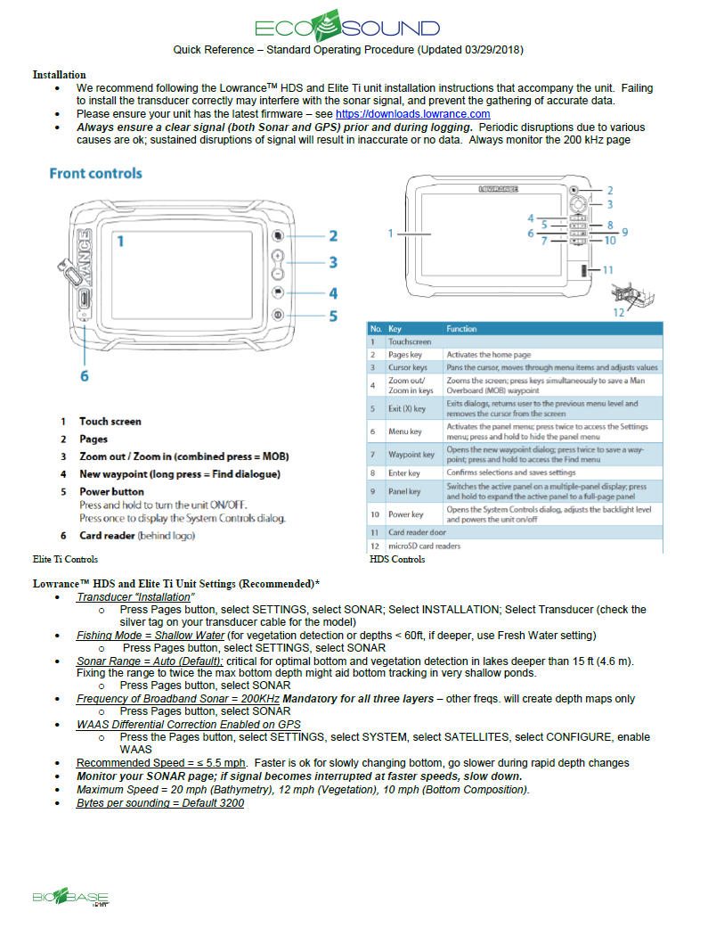

Part 2.

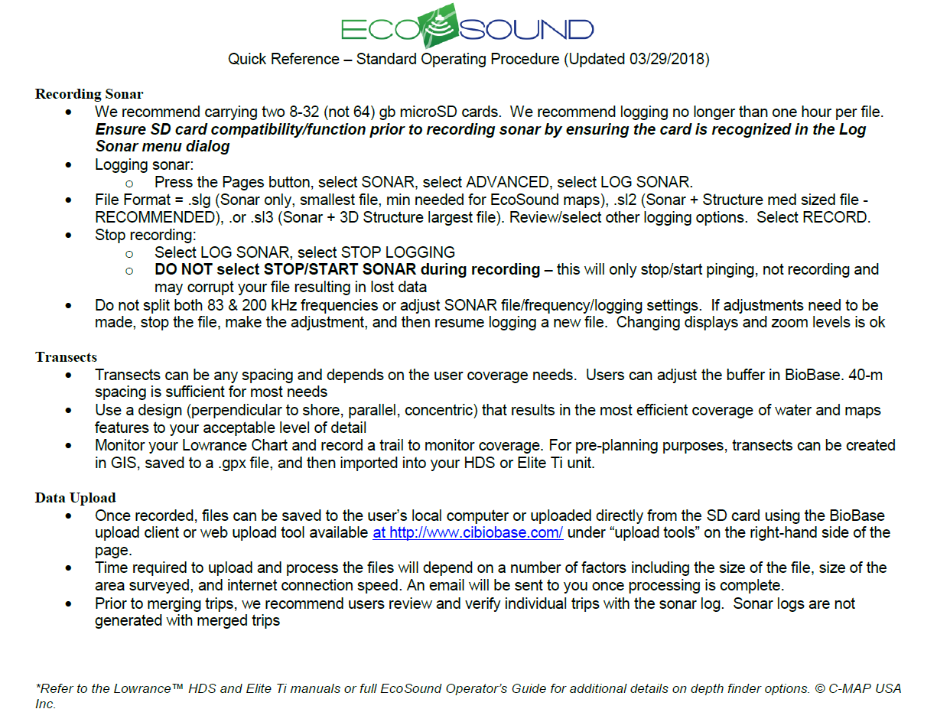

Appendix . Water quality field data sheet.

|  |  |  |  |  |  |
| --- | --- | --- | --- | --- | --- |
| **Lake:** |  |  | **Sampler:** |  |  |
|  |  |  |  |  |  |
| **Date:** |  |  | **Time:** |  |  |
|  |  |  |  |  |  |
|  | **Temperature** | **Specific Conductance** | **Dissolved Oxygen** | **Dissolved Oxygen** | **pH** |
|  | **ºC** | **S/cm** | **mg/L** | **%** |  |
| 1 M |  |  |  |  |  |
| 2 M |  |  |  |  |  |
| 3 M |  |  |  |  |  |
| 4 M |  |  |  |  |  |
| 5 M |  |  |  |  |  |
| 6 M |  |  |  |  |  |
| 7 M |  |  |  |  |  |
| 8 M |  |  |  |  |  |
| 9 M |  |  |  |  |  |
| 10 M |  |  |  |  |  |
| 11 M |  |  |  |  |  |
| 12 M |  |  |  |  |  |
| 13 M |  |  |  |  |  |
| 14 M |  |  |  |  |  |
| 15 M |  |  |  |  |  |
| 16 M |  |  |  |  |  |
| 17 M |  |  |  |  |  |
| 18 M |  |  |  |  |  |
|  |  |  |  |  |  |
| **Visiblity (m):** | |  |  |  |  |
| **Ice Thickness (In):** | |  |  |  |  |
|  |  |  |  |  |  |
| **Comments:** | |  |  |  |  |

Appendix . Stream discharge field data sheet.



1. Tote Road Pike Lakes Restoration: Invasive Northern Pike Eradication Treatment Plan (2017). Unpublished and located at the ADF&G Soldotna Office.
2. Product names used in this publication are included for completeness but do not constitute product endorsement
3. Product names used in this publication are included for completeness but do not constitute product endorsement
4. Soldotna Creek Drainage Restoration: Northern Pike Eradication (2013). Unpublished and located at the ADF&G Soldotna Office